Assignment 25.1

Problem Statement:

Write a Hive program to find the number of medals won by each country in swimming.

Commands:

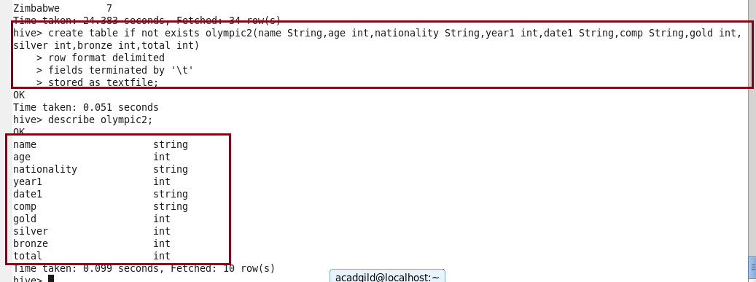

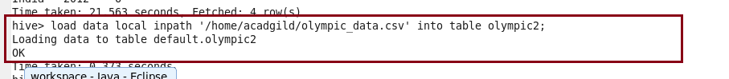

Here, creating table olympic2 and then loading the given dataset into the table.

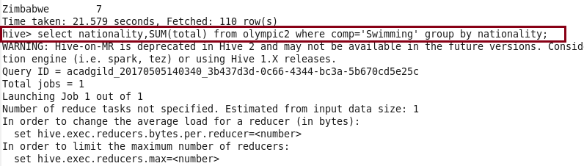

Here, command to find the number of medals won by each country in swimming using SUM function.

Output:

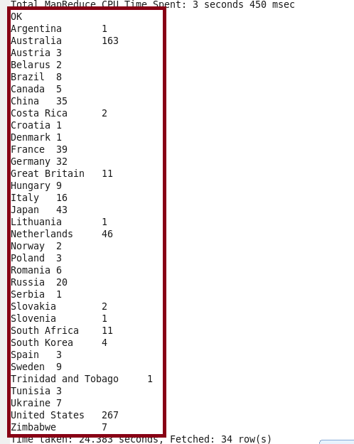

Problem Statement:

Write a Hive program to find the number of medals that India won year wise.

Command:

Here, command to find the number of medals that India won year wise using COUNT function.

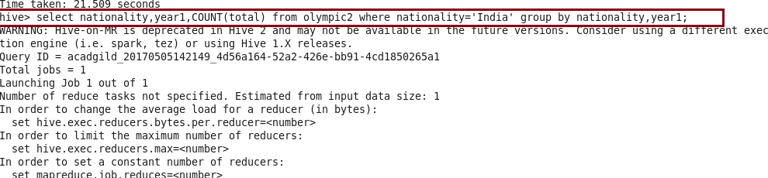

Output:

